Backup local AEM instance

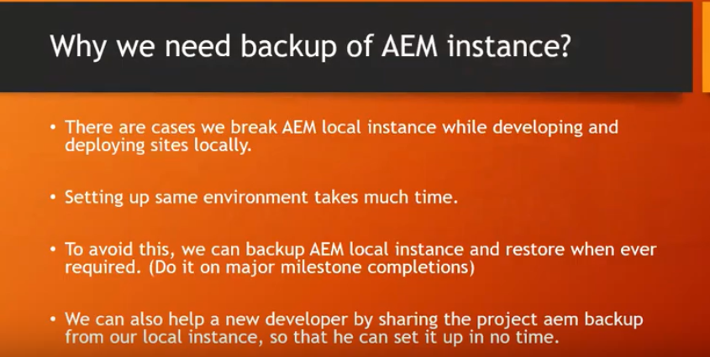

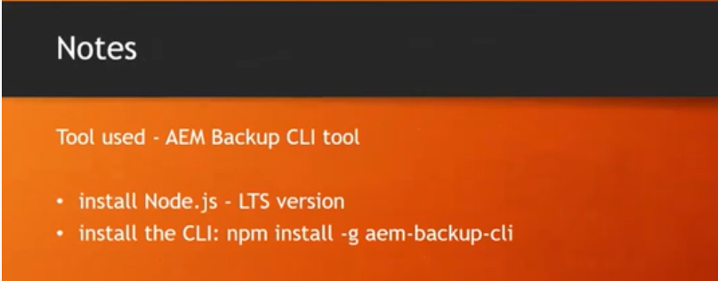

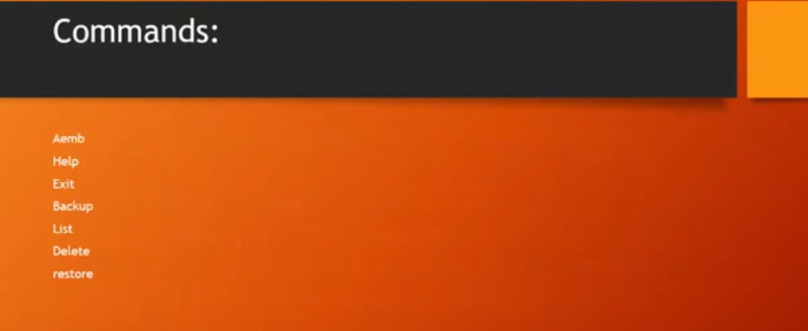

Before proceeding with these commands, we should have the node js installed and CLI tool for aem backup as well.

1. Installing Node JS.

* Go to Node JS official site and download the recommended software to install. <https://nodejs.org/en/>

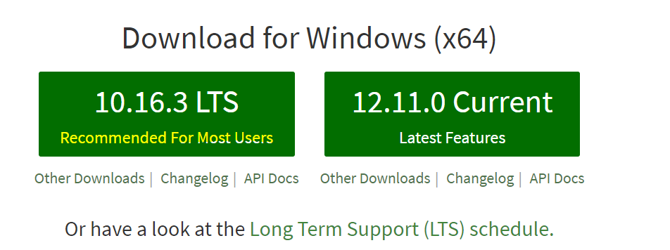

* After downloading, run the “[node-v10.16.3-x64.msi](https://nodejs.org/dist/v10.16.3/node-v10.16.3-x64.msi)” file and click next -> **** to finish the installation.
* To test the successful software installation, run the below command in command prompt (version will be displayed if the software is successfully installed)

“node –v”

“npm –v”

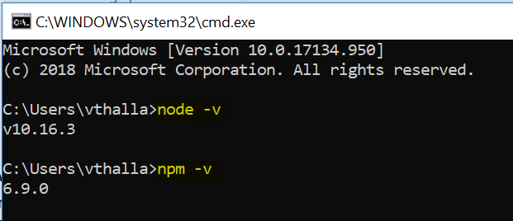

1. Install CLI tool for AEM backup.

* To install CLI tool, use the below mentioned command in command prompt (Node JS installation is the pre-requisite for this)

**Command:** “npm install –g aem-backup-cli”

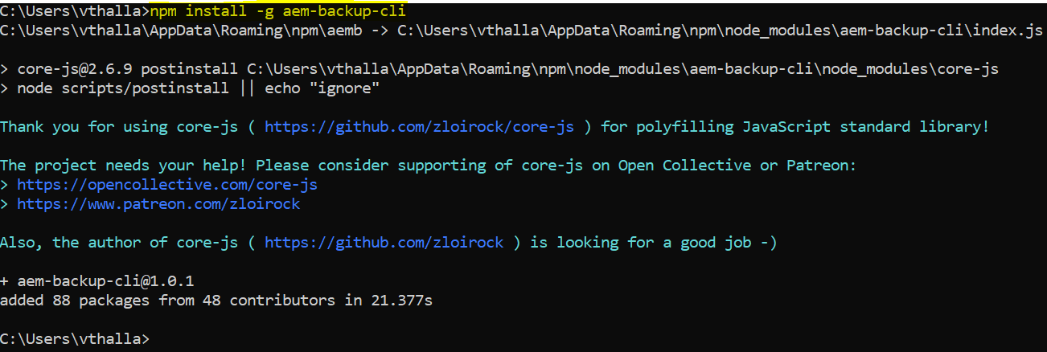

* To verify the successful installation of this CLI tool, run the below command in command prompt.

**Command : “**aemb**”**

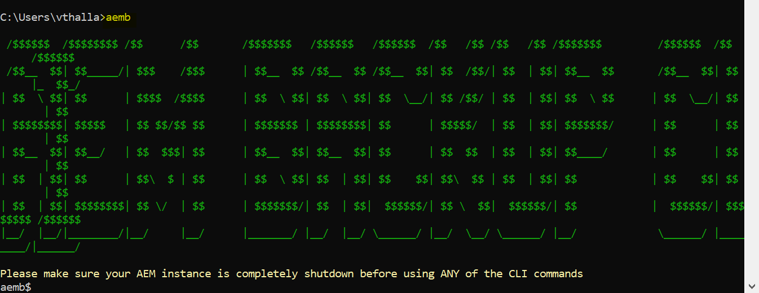

* By running “exit” command, we can come back to this old directory that we were in.



Note:

1. aemb tool will work only inside the aem-installed folder.
2. AEM instance should be stopped to proceed with back-up process.

**Backup process**

Before taking the AEM backup, ensure that the AEM instance is shutdown.

1. As CLI or aemb tool works only inside aem install folder, go to the instance location where we have crx-quickstart folder extracted.



Ex: **“C:\Vinay\******\AEM Server\author”**

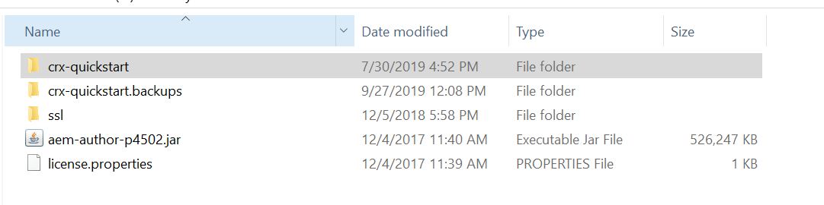

1. After changing the directory to the aem server location, run the “aemb” to proceed with the backup process.

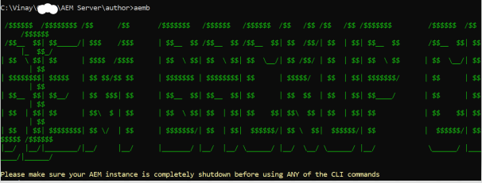

1. Run the following command to start the backup process.

Command : “backup aem-backup-ver1”

Here, “aem-backup-ver1” is the name provided to create the backup package.

1. Once the backup process is completed, we will see the message like shown below.

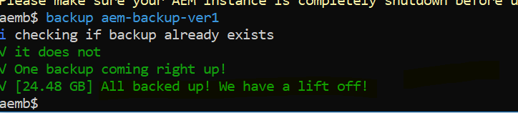

1. A folder with name “crx-quickstart.backups” would get created inside the same location that aem quick start folder is present. Inside this “crx-quickstart.backups” folder, the backup package created would be placed automatically with the same name that was used while running the backup command.

In this case, the backup package with name “aem-backup-ver1” would get created and placed inside “crx-quickstart.backups” folder.

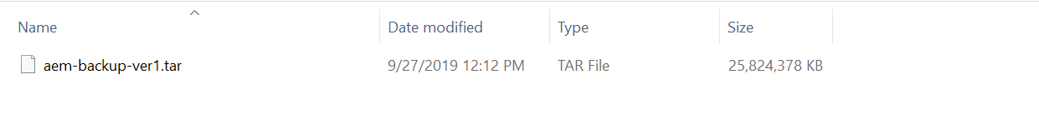

1. To restore the backup versions, we should use “restore” command.